**1. Introduction:**

- Briefly introduce the project and its purpose.

**2. Problem Definition & Design Thinking:**

- Define the problem you aimed to solve with the social media post.

- Explain the design thinking process you followed to address the problem.

**2.1. EMPATHY MAP**

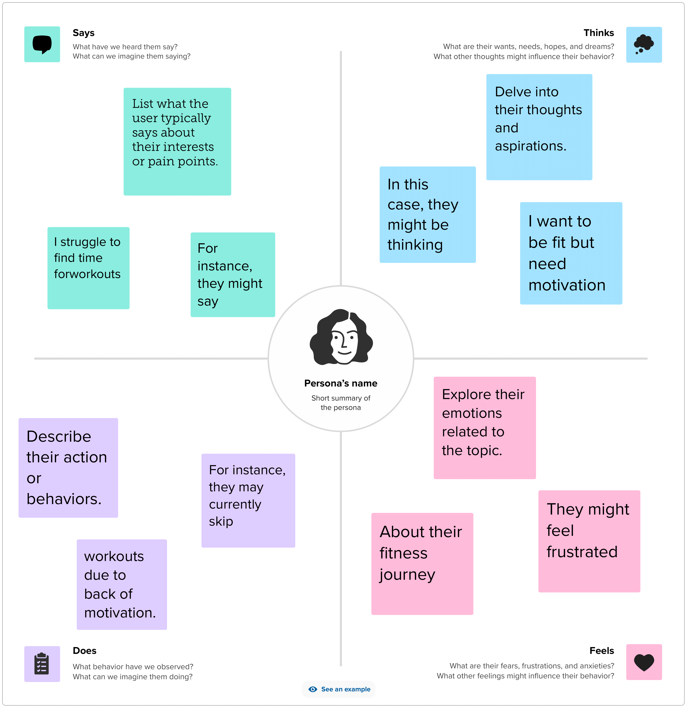

**2.2. IDEATION AND BRAINSTORMING**



**Result:**



**5. Applications:**

- Explain where and how this social media post will be used.

- Discuss its potential impact or value.

**6. Conclusions:**

- Summarize the project's outcomes and what you've learned.

- Reflect on any challenges faced and how you overcame them.

**7. Future Scope:**

- Suggest possible improvements or enhancements for the design.

- Mention any follow-up actions or projects related to this.

**8. Appendix:**

- Include any supplementary materials, such as research data, sketches, or early drafts.

You can use Canva to create visual elements like the social media post and then integrate them into your project demonstration document.